MARMARA UNIVERSITY
FACULTY OF ENGINEERING
COMPUTER ENGINEERING

PHYS1104
PHYSICS LABORATORY
EXPERIMENT 1
Ohm's Law and Resistivity of a Conductor
SXGXE1

NAME | STUDENT NUMBER

Submitted to: Hüseyin YALTIRIK

Experiment Date: 02.03.2020 Due Date: 09.03.2020
1-) PURPOSE
The first aim of this experiment is how to use amperemeter and voltmeter to measure DC voltage and current, the second one is to prove the validity of Ohm’s law, the third purpose is to measure whether several type cables have different resistivity or not.
2-) THEORY
According to Ohm's law, the voltage across a resistor is proportional to the current passing through it:
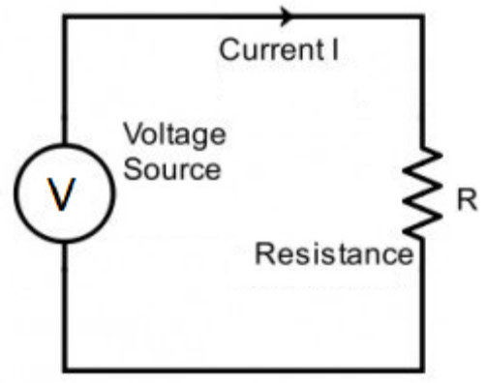
$V = IR$

where the ratio of the voltage (V) over the current (I) is called the resistance (R). The unit of resistance is ohm, which is equal to one volt per ampere.
This law is one of the most fundamental laws of electricity. It helps to calculate the current, voltage, and resistance of an element of an electrical circuit.
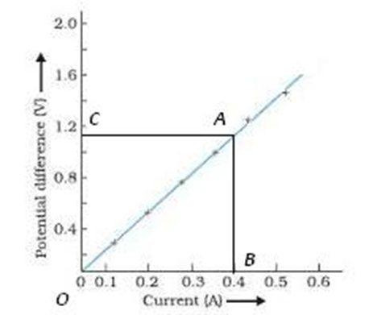
The SI unit of resistance is ohms and is denoted by Ω.
To determine the current-voltage correlation, it is to be shown that the ratio V / I remains constant for a given resistance and accordingly a graph between the potential difference (V) and the current (I) must be a straight line.

For a wire of uniform cross-section, the resistance depends on the length l and the area of cross-section A. It also depends on the temperature of the conductor. At a given temperature the resistance.
$$R=ρ∙\frac{l}{A}$$
Where ρ is the specific resistance or resistivity and is characteristic of the material of wire.
3-) EXPERIMENTAL SETUP
- Board x1
- Copper Wires x2
- Aluminum wire x1
- Dc voltage source x1
- Digital Multimeter x2
- Connection cables 40cm x2
- Banana Plug to Crocodile Alligator Clip x4
- Rheostat x1
Firstly, using the ruler, the cache wire length is measured and recorded. The diameter of each wire is measured and recorded with a micrometer for the section area. The ammeter and rheostat (a variable resistor) are connected in series to the terminals of the voltage source (5 volts). The voltmeter is mounted parallel to the wire terminals. In the rheostat 5 different current values are obtained by adjusting the location of the slider. Potential deviations from the voltmeter within the cable are read and reported for each current value. For each measurement the resistance and resistivity are measured using equations 1 and 2. For every table a voltage and current graph is drawn. The slope of this graph gives the average value of the resistance according to Equation 1. Such measures are repeated for cables that are supplied to you of different types and diameters.

4-) CALCULATIONS & RESULTS
 | Type of Wire | Diameter (m) | Length (m) |  |  | Type of Wire | Diameter (m) | Length (m)
 | Aluminum | 0.0009 | 0.3 |  |  | Aluminum | 0.0009 | 0.15
 | V(v) | I(A) | R(Ω) | $ρ$(Ω.m) |  | V(v) | I(A) | R(Ω) | $ρ$(Ω.m)
1 | 0.45 | 0.32 | 0.55 | 1.17x10⁻⁶ |  | 0.24 | 0.93 | 0.26 | 1.103x10⁻⁶
2 | 011 | 0.21 | 0.52 | 1.10x10⁻⁶ |  | 0.14 | 0.57 | 0.25 | 1.060x10⁻⁶
3 | 0.07 | 0.15 | 0.47 | 0.997x10⁻⁶ |  | 0.08 | 0.38 | 0.21 | 0.891x10⁻⁶
4 | 0.05 | 0.11 | 0.45 | 0.954x10⁻⁶ |  | 0.06 | 0.29 | 0.21 | 0.891x10⁻⁶
5 | 0.03 | 0.07 | 0.43 | 0.912x10⁻⁶ |  | 0.03 | 0.19 | 0.16 | 0.679x10⁻⁶

 | Type of Wire | Diameter (m) | Length (m) |  |  | Type of Wire | Diameter (m) | Length (m)
 | Copper | 0.002 | 0.3 |  |  | Copper | 0.004 | 0.15
 | V(v) | I(A) | R(Ω) | $ρ$(Ω.m) |  | V(v) | I(A) | R(Ω) | $ρ$(Ω.m)
1 | 0.0039 | 0.39 | 0.01 | 1.047x10⁻⁹ |  | 0.0032 | 1.02 | 0.003 | 1.257x10⁻⁹
2 | 0.0031 | 0.31 | 0.01 | 1.047x10⁻⁹ |  | 0.0027 | 0.88 | 0.003 | 1.257x10⁻⁹
3 | 0.0025 | 0.25 | 0.01 | 1.047x10⁻⁹ |  | 0.0019 | 0.61 | 0.003 | 1.257x10⁻⁹
4 | 0.0019 | 0.19 | 0.01 | 1.047x10⁻⁹ |  | 0.0012 | 0.40 | 0.003 | 1.257x10⁻⁹
5 | 0.0016 | 0.16 | 0.01 | 1.047x10⁻⁹ |  | 0.0006 | 0.25 | 0.002 | 1.257x10⁻⁹

Graph-1 Aluminum Wire (30 cm) Current/Voltage Graph

Average resistance: 0.49442 Ω
Graph-2 Aluminum Wire (15 cm) Current/Voltage Graph

Average resistance: 0.0713 Ω

Graph-3 Copper Wire (Fine) Current/Voltage Graph

Average resistance: 0,0018782 Ω
Graph-4 Copper Wire (Thick) Current/Voltage Graph

Average resistance: 0,0014858 Ω
5-) CONCLUSION
Ohm's Law discusses the relationship between voltage and current in an ideal conductor. This relationship expresses: The potential difference (voltage) between an ideal conductor is proportional to the current passing through it. The proportionality constant "resistance" is called R. In this equation, V = IR can be expressed and manipulated to find the other two variables. The general aim is to establish the relationship between current and voltage and current and resistance. Thanks to its freedom from shifting current and voltage, the voltmeter-ammeter system was successfully employed to check Ohm's rule for the ohmic tubular resistor.
6-) REFERENCES
- Marmara University Faculty of Engineering Laboratory Manual
- https://www.seminarsonly.com/Engineering-Projects/Physics/ohms-law.php
- https://en.wikipedia.org/wiki/Ohm%27s_law
- https://www.physicstutorials.org/pt/96-Ohm's_Law_Resistance_and_Resistors#content
7-) APPENDIX
